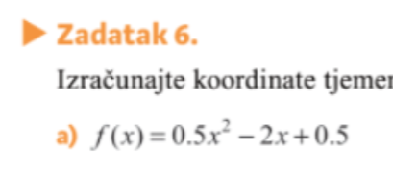
$$x_{0}=\frac{-(-2)}{2∙\frac{1}{2}}=\frac{2}{1}=2$$
$$y_{0}=\frac{4∙\left(0.5\right)∙\left(0.5\right)-{(-2)}^{2}}{4∙0.5}=\frac{1-4}{2}=-\frac{3}{2}$$

$$T(2, -\frac{3}{2})$$
$$f\left(x\right)=a{\left(x-x_{0}\right)}^{2}+y_{0}$$
f(x)=0.5(x-2)²-3/2

Zad 7
X₀=2 y₀=-2
f(x)=a(x-2)²-2 Uvrstit ćemo točku (1,1). Jer ako točka leži na paraboli, smijemo uvrstiti 1 umjesto x i 1 umjesto y

1=a(1-2)²-2
1=a-2
a=3
f(x)=3(x-2)²-2
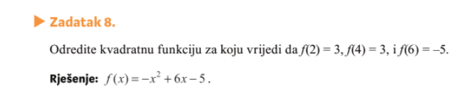
f(x)=ax²+bx+c
$$a∙2^{2}+b∙2+c=3$$
$$a∙4^{2}+b∙4+c=3$$
$$a∙6^{2}+b∙6+c=-5$$

$$4a+2b+c=3/∙(-1)$$
$$16a+4b+c=3/∙(-1)$$
$$36a+6b+c=-5$$
$-4a-2b-c=-3$
$$16a+4b+c=3$$
$$12a+2b=0/:2$$
$$-16a-4b-c=-3$$
$$36a+6b+c=-5$$

$$20a+2b=-8/:2$$
$$6a+b=0/(-1)$$
$$10a+b=-4$$
$-6a-b=0$
$$10a+b=-4$$
$$4a=-4/:4$$
$$a=-1$$

$6∙\left(-1\right)+b=0$
$b=6$, vratim se u neku od jednadžbi i uvrstim a i b da nađem c, c=-5

