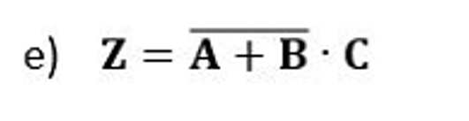
A | B | C | A+B | $$\overline{A+B}$$ | $$\overline{A+B}∙C$$
0 | 0 | 0 | 0 | 1 | 0
0 | 0 | 1 | 0 | 1 | 1
0 | 1 | 0 | 1 | 0 | 0
0 | 1 | 1 | 1 | 0 | 0
1 | 0 | 0 | 1 | 0 | 0
1 | 0 | 1 | 1 | 0 | 0
1 | 1 | 0 | 1 | 0 | 0
1 | 1 | 1 | 1 | 0 | 0
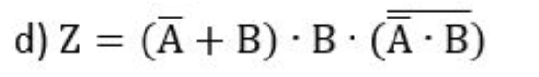
$$Z=\left(\overline{A}∙B+B∙B\right)∙\left(\overset{̿}{A}+\overline{B}\right)=\left(\overline{A}∙B+B\right)\left(A+\overline{B}\right)=B\left(\overline{A}+1\right)\left(A+\overline{B}\right)=B\left(A+\overline{B}\right)=B∙A+B∙\overline{B}=A∙B$$
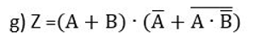
$$z=\left(A+B\right)∙\left(\overline{A}+\overline{A}+\overset{̿}{B}\right)=\left(A+B\right)∙\left(\overline{A}+B\right)=A∙\overline{A}+A∙B+B∙\overline{A}+B∙B=A∙B+B∙\overline{A}+B=B\left(A+\overline{A}+1\right)=B$$

