Slavica Singer, Nataša Šarlija, Sanja Pfeifer, Sunčica Oberman Peterka

**Gender patterns of businesses with growth potential in Croatia**

ACKNOWLEDGMENT

This work is funded by Croatian Science Foundation under Grant No. 3933 Development and application of growth potential prediction models for SMEs in Croatia

1. **Introduction**

Innovative businesses are an elite minority in any developed or developing economy, and are essential for building sustainable competitiveness, creating new jobs, well-being and fair societal infrastructure.

Both women and men are expected to bring innovation in all aspects of our lives, but there are less women in those activities across the world than it would be expected according to the women’s population share. This is also the case in Croatia, a country experiencing mega changes of the political, economic and social system after the 1991 splitting of former Yugoslavia, the human and material devastation during 1991-1995 war and the slowest path of getting out of the 2008 economic crisis. One of the highest unemployment rates, especially among young people (48.6%, 2014, Q4, Eurostat, Unemployment Statistics) and the lowest expected employment rate in the EU for 2020 (63%) make Croatia economically, socially and politically vulnerable. In such context, activities related to creating new jobs are of the utmost importance and anyone’s knowledge, skills and commitment lost in this process is socially and politically unaccountable. Using this angle and aggregated Global Entrepreneurship Monitor (GEM) data from the 2003-2013 period, the chapter presents several gender patterns of businesses with growth potential in Croatia[1].

1. **Literature review / theoretical background**

Gender patterns of businesses with growth potential can be explored from many angles (e. g. theory of the firm, entrepreneurship, inclusion, macroeconomic aspects of using resources, etc.). In this research, some key theoretical concepts related to firm growth, entrepreneurship, innovation and inclusion are discussed for framing the research questions (hypotheses).

The literature review confirms that researchers’ interest is typically more focused on why and how businesses are created, and much less why and how they grow. Despite the existence of many studies on enterprise growth stages, the study of a firm’s growth patterns under the influence of internal and external factors is limited (Gupta et al., 2013)If the gender aspect is added, even less research findings can be found. Research on business growth has been prominent in the last 50 years, while research on gender and business growth just in the last 20 years, and mostly in a number of specific countries.

* 1. **On firm growth and entrepreneurship**

In the broadest sense, firm growth can be explained by improvements in some aspects of its vitality (competitiveness, profitability), over a period of time, not only at a point in time (e.g. one year). Since Penrose (1959) found that firm size results from its growth capability, and that growth results from the firm’s effective and innovative managerial resources, many new insights emerged, and some old questions remained open. While there is an obvious consensus about the importance of business growth, especially due to the fact that fast-growing businesses are rare, but valuable to national economies because of their value adding contribution (e.g. Shane and Venkataraman, 2000, Delmar, Davidson and Gartner, 2003), much less is known about growth drivers and dynamics. For example, Bartelsman et al. (2005) analysis of post-entry performance of new firms in seven OECD countries found that about 20-40 percent of them fail within the first two years, and only 40-50 percent survive beyond the seventh year. Such results invite further research into factors enabling or preventing growth.

Research findings to date are far from reaching a consensus on why business growth is rare. A possible cause is that research approaches often analyze one or another dimension of business growth that produces many different indicators, and lose sight of the multi-faceted features of business growth, failing to build a holistic understanding of the business growth phenomenon.

Gibb (2000) made an interesting point about two parallel processes – increased interest in searching growth phenomena is matched by increased ignorance of them, leaving numerous “mythical concepts” and “myths” alive. Firm growth research led to some unchallenged assumptions about development processes that have been implicitly adopted and recycled by policy-makers. At the same time, it challenges social sciences researchers , especially in understanding the growth of business venturing.

In the same vein, Leitch, Hill and Neergaard (2010), ten years later, argue that little is known about the growth phenomenon and that a lot of confusion and misunderstanding is still around. They suggest to move from a “change in amount” format to a “growth as a process”, and also insist on inclusivity and pluralism in researching the growth phenomenon.

One such approach is the life cycle concept, which is widely used, but also criticized. The life cycle concept explicitly brings the time dimension in understanding the process of growth – a dimension that is often forgotten, despite the fact that each growth process always takes place along some timeline. The importance of the life cycle concept lies in understanding that changes in each development phase require a different set of entrepreneurial capabilities, organizational structure and innovation strategies. Using psychological findings which suggest that individual behavior is determined mostly by previous experience, Greiner (1972) argues that “the future of an organization may be less determined by outside forces than it is by the organization’s history”. Greiner brought thus individual behavior to the centre of understanding the concept of a firm’s life cycle . Greiner suggests that each firm experiences phases of evolution (prolonged period of growth without major organizational challenges) interrupted by crisis / phases of revolution (with substantial changes of organizational life).

Adizes (1979) connected the organizational life cycle concept with entrepreneurship, by emphasizing the need of re-configuration of resources (including self-commitment, vision, risk-taking capacity, etc.) and activities along the growth process , in order to capture emerging opportunities. By this, Adizes departs from the traditional life cycle concept based on programmatic stages and is in some way closer to more recent work of Levie and Lichtenstein (2010), who challenged the validity of the life cycle concept, especially on the grounds of not capturing the complexity of the business growth. They concluded that the modelling of growth stages has hit a dead end.

Levie and Lichtenstein (2010) propose a dynamic states approach, which is based on a “network of beliefs, relationships, systems and structures that convert opportunity tension into tangible value for an organization’s customers/clients, generating new resources that maintain the dynamic state.” (p. 33). The ability to change the destiny of an organization by using available resources and co-create opportunity is emphasized in several concepts grounded in systems theory. such as the view of a firm as an energy-conversion system (Slevin and Covin, 1997), among the properties of emerging organizations (Katz and Gartner, 1988), as part of effectuation (Sarasvathy, 2001), or generative emergence (Lichtenstein, 2014).

Such approaches bring together different theoretical perspectives, like the resource-based perspective, the motivation perspective, the strategic adaptation perspective and the configuration perspective.

The literature provides insights into the empirical testing of some features of business growth discussed above. Kolvereid and Bullvag (1996) showed the existence of a relationship between entrepreneurs’ growth intentions and actual firm growth, and concluded that growth intentions can predict actual growth. Storey (1994) identified three factors for growth: the entrepreneur, the firm, and the strategy, which adds to understanding that growth of small businesses is influenced by a complex set of interrelated factors.

Cooney (2012) finds broad agreement among scholars about the primary drivers of business growth, i.e. (1) motivation, (2) resources and (3) market opportunities, and emphasizes the role of owner and his motivation. This view is supported by Orser (1997) who found that “those firms whose owners had stated five years previously that they wanted to grow the business were now more successful, while the majority of firms owned by entrepreneurs who did not prioritize growth had either not grown or had failed.” (Cooney, 2012, p. 3).

Besides internal factors (such as intentions), the role of the entrepreneurial ecosystem in business growth has been recognized. Davidsson (1989) warned that a complicated regulatory system and an unfavorable tax system can reduce the willingness of small businesses to grow. Lumpkin and Dess (1996) made a major contribution to understanding the multidimensional feature of an entrepreneurial orientation construct (autonomy, innovativeness, proactiveness, risk-taking and competitive aggressiveness) and its relationship with the firm’s performance, by adding environmental and organizational factors.

The lack of internationally comparable data about entrepreneurship contributed to the absence of insights into how much contextual differences influence the entrepreneurial capability of a country across the world. Building on a holistic approach, and trying to capture multi-faceted features of entrepreneurship, the Global Entrepreneurship Monitor (GEM) built a conceptual framework that assumes interactions between an entrepreneurial ecosystem and an individual (described by a set of attributes and perceptions of societal values) in the venturing process (identified in two stages: the first 42 months, and after the first 42 months), as presented in Figure 1. GEM collects such data on a yearly basis in around 70 countries which cover around 90% of the world’s GDP (the collection of data started in 1999, so for many countries longitudinal data are available as well).

Figure 1 - The GEM Conceptual Framework

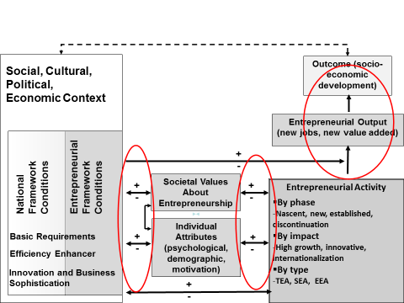

Source: Kelley, et al. (2016), p. 12

The GEM database can be used to check if specific patterns of entrepreneurial activities can be recognized across different countries and different economies.

GEM special reports on high-growth entrepreneurship (Autio, 2006; Autio, 2007), then the joint report on high-impact entrepreneurship published with Endeavor (2011) and the report *Entrepreneurship, Competitiveness and Development*, jointly developed and published with the World Economic Forum (2015) provide insights into multi-faceted aspects of business growth and provide some answers of why and how some businesses grow or not.

* 1. **On gender and business growth**

The gender issue is approached more often from the human rights angle, and less from resource efficiency aspect.

Since 2006, the World Economic Forum has been producing the Global Gender Gap Index, which measures the gap between men and women in four categories (sub-indexes): Economic Participation and Opportunity, Educational Attainment, Health and Survival and Political Empowerment. In the discussion on gender patterns in business growth, some research indicated that the gap in educational attainment can be a limiting factor for women’s involvement in business growth, but this hypothesis has been disproven. In general, gaps in health and educational attainment are almost closed (145 countries covered in the 2015 Report have closed almost 96% of the gap in health outcomes between women and men, and 95% of the gap in educational attainment). However, the gaps between women and men in economic participation and political empowerment are still very wide: only 59% of the economic outcomes gap and 23% of the political outcomes gap have been closed.

GEM is surveying, additionally to its regular annual survey, entrepreneurship from a gender perspective. GEM special reports on women’s entrepreneurship were published for the years 2006 (Allen et al, 2007), 2007 (Allen et al., 2008), 2010 (Kelley et al., 2011), 2012 (Kelley et al., 2013) and 2015 (Kelley et al., 2015). The purpose of the GEM Women’s reports is to learn about similarities and differences in the frequency and nature of women’s entrepreneurship, compared to men, across various economies. Specifically, the reports provide information on female entrepreneurship rates and gender gaps in the following key areas:

* Participation in multiple phases of activity
* Characteristics and motivations of women entrepreneurs
* Societal attitudes about entrepreneurship
* Impact indicators

The GEM data confirm the existence of the gender economic outcomes gap, not only by measuring the intensity of entrepreneurial activities, but also the motivational aspect. Compared with men, women are less entrepreneurially active and their motivation for entrepreneurship is less based on opportunity recognition. Pines et al. (2010) showed that equality in entrepreneurial activities (measured by the percent of women entrepreneurs) is higher in countries where the general income per capita is small, and where women have no other option for making a living. It looks that poverty is more equalizing women and men in entrepreneurial activity than any other factor.

Gender-related difference in performance of business ventures (e.g. measured through export orientation, jobs creation…) is also confirmed by GEM surveys, and is a topic of interest for researchers. Loscocco et al. (1991) researched why women generate lower

sales volumes and derive less income than their male counterparts. They concluded that different characteristics of the owner and the small business, based on gender criteria, explain this gap in business performance. The smaller size of businesses owned by women is the major explanatory factor, followed by women’s lack of experience and their concentration in the least profitable industries.

Rosa et al. (1996) surveyed 600 (300 women, 300 men) Scottish and English small business owner-managers. Their analysis suggests that the relationship between gender and small business performance is complex, and gender appears to be a significant determinant even after other key factors are controlled for. On the contrary, Johnsen and McMahon (2005) found no consistent statistically significant differences in financial performance and business growth between female and male owner-managed businesses, if appropriate demographic and other relevant controlling influences are taken into account.

Tominc and Rebernik (2006) searched individual attributes of Slovenian entrepreneurs using gender criteria and found that women, on average, do not start their entrepreneurial ventures with lower expectations than men. This suggests that there is no inherent reason for women to be less effective than men during their entrepreneurial careers. It opens some other questions related to the structure and quality of business environment in which women and men function. Coleman and Robb (2014) analyzed access to capital by high-growth women-owned businesses for the US National Women’s Business Council, and found that women-owned firms exceeded their own growth expectations in the period 2008-2011 (despite the fact that the women were less likely than men to expect rapid firm growth, defined by number of employees).

Fairlie and Robb (2009) surveyed the performance of female-owned businesses, compared to male-owned businesses, by using confidential data from the U.S. Census Bureau. They found that female-owned businesses are less successful than male-owned businesses because they have less startup capital and less business human capital (less prior work experience in similar business, and less prior experience in a family business). They also found that women business owners work fewer hours and may have different preferences for the goals of their business.

Few researchers make an explicit analysis of gender imbalance in entrepreneurial activity as an economic resource issue. Tominc and Rebernik (2006) recognize that “women represent an unexploited resource for entrepreneurship” (p. 50). This brings back the issue of the gender economic performance gap and the need to learn more about its causes.

1. **The case of Croatia**

Croatia is a small country with a 4, 2 million-population (2014), with the tendency of rapid aging and depopulation. It has a GDP per capita of USD 13,494 (2014) and an SMEs contribution to GDP of 54% (2014). The Croatian economy is in transition from an efficiency-driven to an innovation-driven development phase, according to the classification used by the World Economic Forum.

Before the global financial crisis of 2008-2009, the Croatian economy grew at 4-5% annually, but the effects of the crisis locked Croatia in six years of recession. Some very weak signs of slow improvement came only in 2015.

Croatia experienced two mega changes at the beginning of 1990’s. First, after the splitting of former Yugoslavia in 1991, changes caused by the introduction of a parliamentary democracy and a full market economy required new knowledge and skills in running the country and businesses, as well as a new institutional infrastructure. Secondly, from 1991 to1995, Croatia had the war, and only at the beginning of 1998 all occupied territories which were under UN control were re-integrated back to Croatia. Those two mega changes were accompanied by staggering problems of a very corrupt privatization process, huge war devastation of human, physical and economic resources, slow process of institutional restructuring needed to serve new political (democratic) and economic system (market economy), and lack of national consensus on strategic priorities for the country. Also, in order to build a new institutional structure, the education system was challenged, and did not respond fast enough to the changing needs of the society.

The intensity of changes can be illustrated by the changed structure of employment in Croatia: employment in small enterprises doubled, while employment in medium and large enterprises halved in 2000 relative to 1990, but the education sector stayed “business as usual”, not reacting to such change.

International surveys on competitiveness (World Economic Forum), entrepreneurship (Global Entrepreneurship Monitor), and innovation (Innovation Union Scoreboards) confirm each other in regard to low innovativeness, low share of growing businesses and persisting gap in entrepreneurial activities using gender criteria.

Croatia’s competitiveness profile showed deterioration from 2002 to 2015, when Croatia slipped from the 50s to the 70s rank and has kept this position unchanged for several years. Inefficient government bureaucracy, policy instability, tax rates, access to finance, and restrictive labor regulations have been constantly identified as the most problematic factors (Schwab (ed.), 2015).

According to the 2015 Innovation Union Scoreboard, Croatia is a moderate innovator. Innovation performance improved until 2011 and then declined, slightly recovering in 2013. Croatia is performing below the EU average in most dimensions, but is above the EU average in Human resources (due to the educational level). The weakest performing dimension is the quality of research systems, but also all dimensions related to SMEs (product/process innovations, marketing/organizational innovations, collaboration of innovative SMEs) are below the EU average.

The entrepreneurship capability of Croatia has been regularly monitored since 2002 through participation in the GEM survey. It positions Croatia as a country in transition from an efficiency-driven economy to an innovation-driven economy, with a very low motivational index (ratio between new ventures started out of recognized opportunities and those started out of necessity, i.e. because of the lack of other choices). A value of the index below 1 indicates more new ventures started out of the necessity. Croatia’s motivational index of only 1.0 in 2015 is lower than the average value of motivational index in efficiency-driven economies (2.0), and is even lower than in factor-driven economies (1.5). Innovation-driven economies have a motivational index at the level of 3.4, with the highest values for Switzerland (6.5) and Norway (6.3) (Kelley et al., 2016).

Another feature of Croatia’s entrepreneurship capacity is the low innovation level (measured by the percentage of new ventures with new products to all or without strong competition). The average value of this indicator for efficiency-driven economies is 24%, and for Croatia it is 16.9%, which is lower than the average of this indicator in factor-driven economies (Kelley et al., 2016).

The third important feature, relevant for this survey, is the gender perspective of entrepreneurial activities: in Croatia only 5.7% of women are entrepreneurially active vs. 13.0% of women in efficiency-driven economies, and 46.1% of entrepreneurially active women started their venture out of the necessity vs. 33% in efficiency-driven economies. (Kelley et al., 2016).

Additionally, Kelley et al. (2014) indicated that Croatia has a deficit of innovative female businesses, compared to the average of efficiency-driven economies in Europe (Figure 2). More than in the European efficiency-driven economies, female entrepreneurs in Croatia are in business services sector, they are more ambitious, measured by the indicator of expected job creation (6 and more jobs in next five years), and they are more oriented toward international markets.

Figure 2 - Croatia vs. European efficiency-driven economies – business policy indicators

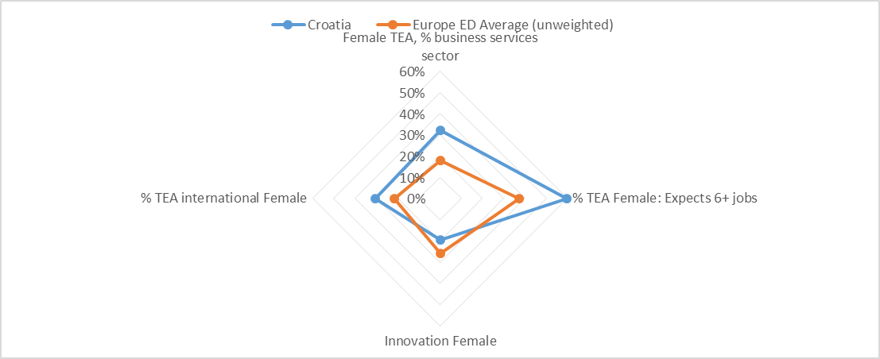

ED – efficiency-driven economies

Source: Kelley et al. (2014)

At the same time, GEM survey on gender aspects of entrepreneurial activity warned that Croatia is suffering from a low perception of opportunities among women and less networking (knowing an entrepreneur) than it is characteristic for European efficiency-driven economies (Figure 3).

Figure 3 - Croatia vs. European efficiency-driven economies – on individual perceived attributes

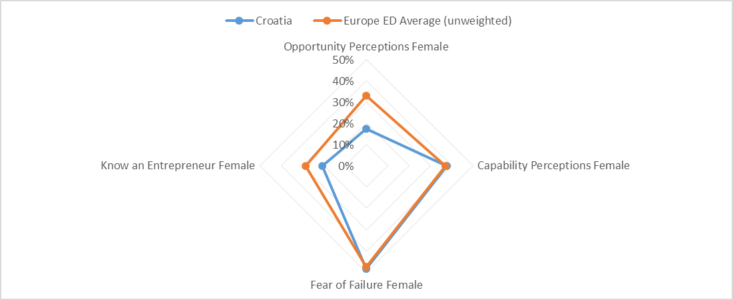

ED – efficiency-driven economies

Source: Kelley et al. (2014)

From the regional perspective of the Danube region[2] (Tominc et al., 2015), Croatia shows much less appreciation for successful entrepreneurs, and there are also less perceived opportunities (Figure 4).

Figure 4 - Entrepreneurial profile of Croatia from the Danube region perspective, based on GEM entrepreneurial attributes and societal values

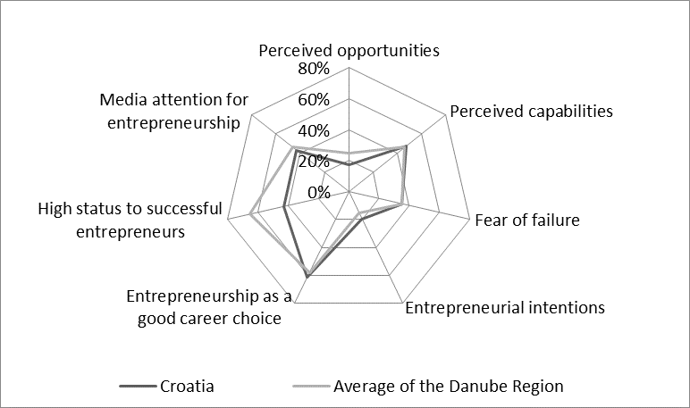

Source: Tominc et al. 2015, p. 33

Since entrepreneurial activity is happening in an entrepreneurial ecosystem, it is important to know how supportive or hindering the system is. Figure 5 provides a comparison of the quality of the different dimensions of Croatian entrepreneurial eco-system with the average of countries in the same development phase (efficiency-driven economies), involved in the GEM survey:

Figure 5 - Expert rating of the Entrepreneurial Ecosystem, 2015

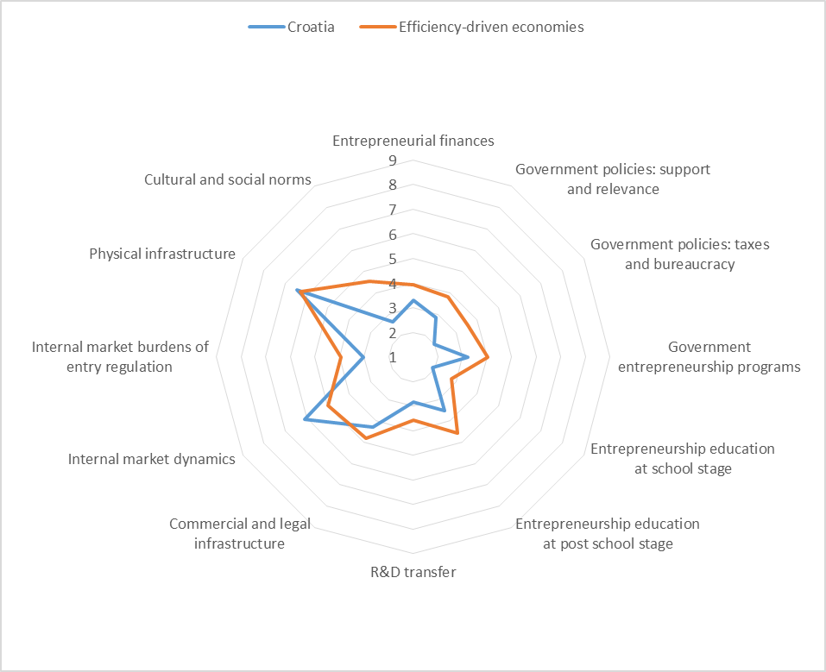

Source: GEM database, 2016, Croatia GEM team, CEPOR

1: highly insufficient, 9: highly sufficient

Experts’ evaluation of two public policies that are relevant for this survey (women’s support to business start-ups, attention to high growth) and interest of businesses in innovation (on a scale of 1 – lowest to 5 –highest), provide an additional insight into the entrepreneurial ecosystem of Croatia (GEM database, Croatia GEM team):

* Women’s support to business start-up: in the 2002-2013 period average scores for Croatia grew from 2.71 to 3.01, while in countries like Island, Finland and Norway the scores were above 4.
* Attention to high growth: in the 2005-2013 period, average scores for Croatia grew from 2.52 to 2.69, and almost in all these years Ireland had a score above 4.
* Interest in innovation, from the perspective of the business sector: in the 2007-2013 period average scores for Croatia have oscillated between 2.5 and 2.78, while in countries like Singapore, UAE, Island and Taiwan the scores were above 4 or close to 4.

Entrepreneurial activity in Croatia is performed in the context described above, which provides the broadest framework in which gender patterns of businesses with growth potential will be analyzed.

1. **Conceptual framework and hypothesis**

It is well documented in the literature that the growth potential of businesses is based on their innovative capacity (in offering new products/services, using new technologies, penetrating on new markets), which is also related to the owner’s motivation, as discussed in the literature review section. Using GEM data for Croatia, Sarlija and Pfeifer (2015) found that “innovative orientations vary with personnel, firm, meso and macro level variables, and between different stages in entrepreneurship process. Significant predictors are the occupation of the entrepreneurs, the size of the firm and export aspirations for both early stage and established entrepreneurs. In addition, fear of failure, expecting to start a new business and seeing an entrepreneurial career as a desirable choice are predictors of the innovative orientation among early stage entrepreneurs” (p.1).

This research intends to determine if gender patterns can be identified among cohorts of innovative and non-innovative entrepreneurs.

The identification of research hypotheses relies on a fragment of the GEM conceptual framework (Figure 6) and its extension showing phases of business venturing (early-stage - up to 42 months, and established - after 42 months) and the clusters of variables assumed to have an influence on that (Figure 7).

Figure 6 - GEM conceptual framework (fragment used for testing assumed relationships)

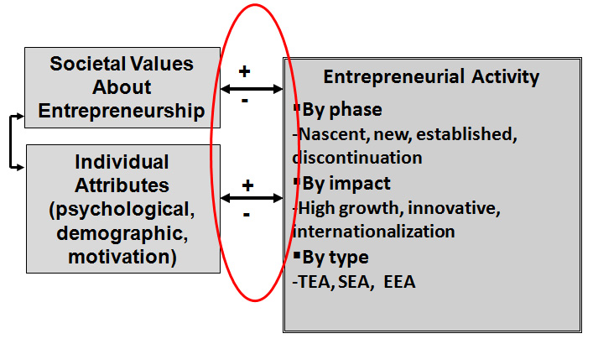

Figure 7 - Model of Business Phases and Entrepreneurship Characteristics as presented in GEM

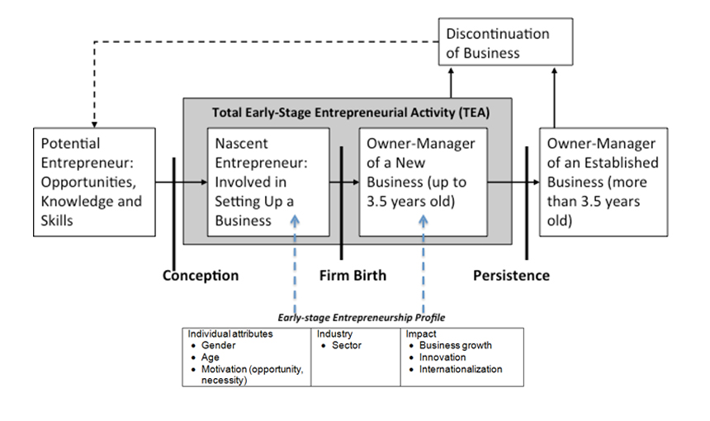

Source: Kelley et al. (2016), p. 13

Additionally, the analysis will be focused on differences between early-stage businesses (up to 42 months at the moment of surveys) and established businesses (older than 42 months), based on personal demographics and attributes, firm demographics and impact (business growth, innovation, internationalization) using gender lenses. By differentiating between early-stage businesses and established businesses, this research is testing the viability of the approach suggested by Levie and Lichtenstein (2010), who argue that the traditional life cycle concept should be replaced by a dynamic states approach in which a differentiated network of beliefs of individuals play an important role, as discussed in the literature review section.

The assumed differences between “innovative” and “non-innovative” women and men will be tested through the following research hypotheses:

H1: There is a significant difference between innovative women and innovative men, based on independent variables clustered as personal demographics, personal attributes and societal values, firm demographics and firm innovation strategies.

H2: There is a significant difference between innovative and non-innovative women, based on independent variables clustered as personal demographics, personal attributes and societal values, firm demographics and firm innovation strategies.

H3: There is a significant difference between innovative and non-innovative men, based on independent variables clustered as personal demographics, personal attributes and societal values, firm demographics and firm innovation strategies.

Innovative individuals represent the dependent variable, described by gender, newness of products, newness of technology and exposure to competition. All other variables are independent ones.

1. **Data, Variables, Sample and Method**

**Data sources and variables used in testing the hypotheses**

In order to identify the gender patterns of businesses with growth potential in Croatia, the

GEM data set for Croatia was used, which is collected by using several instruments. For the purpose of this analysis, data collected through the Adult Population Survey (APS) are used. This instrument is a standardized questionnaire, covering a very broad set of data on entrepreneurial attributes and activities of sampled individuals.

By using data from APS questionnaire (detailed description of variables is presented in the Appendix - Table 1), four clusters of variables were built:

1. Personal demographics (gender, age, household size, work status, income level, education)
2. Personal attributes and societal values (knowing an entrepreneur, perceived opportunities for starting a business, perceived capabilities for starting a business, fear of failure, intentions to start a business; societal values toward entrepreneurship: desirable career choice, high level of status, media attention to successful new businesses)
3. Firm demographics (ownership, management, number of employees)
4. Firm innovation strategy (newness of products, newness of technology, exposure to competitors, internationalization, expected job creation)

Since the GEM survey is conducted on a sample of a minimum size of 2000 randomly selected adults, based on criteria of age and gender, a one-year data set would not be sufficient to recognize gender patterns of businesses with growth potential. Therefore, the data set of selected items from the APS questionnaire was built for the period 2003-2013, which provided adequate stock of data to test the hypotheses.

**Sample**

In Croatia, the GEM survey is conducted on the sample of 2000 adults, 18-64 years of age, from 2002. The sample provides insights into entrepreneurial attributes and activities of individuals engaged in (a) early-stage entrepreneurial ventures (an adult who starts, manages and owns, fully or partially a business not older than 42 months), and (b) established ventures (an adult who manages and owns, fully or partially a business older than 42 months). In order to assess the gender patterns of businesses with growth potential, an additional structuring of the sample was implemented, using the gender and the innovative capacity of entrepreneurs. The whole structure of the sample is presented in Table 1.

Table 1 - Sample, based on APS Croatia 2003-2013 aggregated data set

|  |  |  |  |  |  |
| --- | --- | --- | --- | --- | --- |
|  | | Early-stage entrepreneurs (ventures less old than 42 months) | | Established entrepreneurs (ventures older than 42 months) | |
| number | % | Number | % |
| Innovative entrepreneurs | Women | 137 | 10.3 | 69 | 10.1 |
| Men | 375 | 28.2 | 140 | 20.6 |
| Non-innovative entrepreneurs | Women | 256 | 19.2 | 164 | 24.2 |
| Men | 564 | 42.3 | 306 | 45.1 |
| Total | | 1332 | 100 | 679 | 100 |

**Method**

Building insights into the gender patterns of businesses with growth potential in Croatia, and testing the identified hypotheses relied on descriptive statistics, t-test and Chi-square test. The t-test was used to test differences between two means and the chi-square test was used to test dependence between categorical variables [Sheskin, 2004].

1. **Findings**

The applied analysis confirmed all three hypotheses by identifying significant differences between some variables, as it is shown in Table 2 (a, b), Table 3 (a, b) and Table 4 (a, b) (in the appendix). In summary, there are distinctive patterns of businesses with growth potential:

* depending on gender
* depending on the stage of business venturing,
* depending on the criteria of innovativeness in the cohorts of women and men (innovative and non-innovative)

*H1: There is a significant difference between* ***innovative women and innovative men****, based on independent variables clustered as personal demographics, personal attributes and societal values, firm demographics and firm innovation strategies - CONFIRMED*

Distinctive differences between innovative men and innovative women in both stages of venturing (early-stage and established) were identified.

***Early-stage venturing (innovative women and innovative men)***

For this stage of venturing, the difference between innovative women and men stems from the following variables (Figure 8):

* ***household income*** - entrepreneurially active innovative men come from households with higher household income: 57.5% men belongs to the upper 33%tile vs. 44.4% innovative women
* ***working status*** – there is a higher share of men with self-employed status then women (30.0% vs. 22.3%); and higher share of full-time status among women than among men (50.5% vs. 46.1%)
* ***reason for venturing*** - higher share of men starting a business because of taking the advantage of a recognized opportunity than women (54.1% vs. 40.4%). There are more women who started a business because they did not have a better choice for work (42.9% vs. 32.1%)
* ***export orientation*** – despite the fact that both women and men are at the same level of not exporting, there is an important difference among those who are exporting. Men export more (39% of them export 26% or more of annual sales), while only 23.3% of women do the same.
* ***expected new jobs in 5 years*** – men have much more ambitious expectations for creating new jobs comparing to women (34.8% vs. 12.3%).

Figure 8 - Gender pattern of businesses with growth potential – early-stage entrepreneurs, Croatia

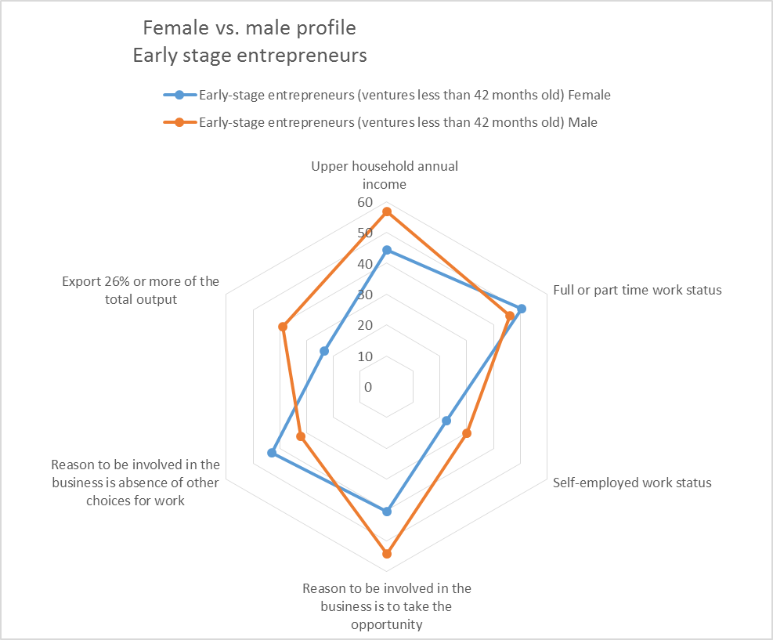

***Established venturing (innovative women and innovative men)***

For this stage of venturing, the difference between innovative women and men stems from more variables than in the case of early-stage venturing. Only three variables are the same as in the case of early-stage venturing (household income, working status and expectations about new jobs in next five years). It indicates that the stage of venturing plays a role in activating a differentiated set of influential variables, as it was also argued by Levie and Lichtenstein (2010) in their concept of dynamic states of venturing. The difference between innovative men and innovative women emerges from the following variables (Figure 9):

* ***household size*** – innovative men come from a bigger household than women (3.8 members vs. 3.4 members)
* ***household income*** – as in the case of early-stage venturing, innovative men come from households with higher household income: 57.3% men belongs to upper 33%tile vs. 42.4% innovative women
* ***working status*** - higher share of men with self-employed status than among women (62.20% vs. 41.1%);
* ***know an entrepreneur*** (as an indicator of capability of networking and using other’s people experience) – three times more men are better connected / networked than women (74% vs. 25.7%)
* ***perception about own knowledge and skills*** needed for running a business is quite high among both groups, but men are much more self-confident (99.3% vs. 84.9%)
* ***societal status of successful entrepreneurs*** – more than half of both groups think that successful entrepreneurs do not have high societal status, but women are more critical (52.2% of men vs. 67.2% of women).
* ***number of employees*** – innovative women have much smaller businesses than men (3.1 employees vs. 13.9 employees)
* ***expected new jobs in 5 years*** – innovative men have 5 times higher expectations about creating new jobs in the next five years than women (20.1% vs. 4.8%).

Analyzing both groups together, it looks like women are more cautious / conservative in developing own businesses (smaller businesses according the number of employees, expected creation of new jobs). Both groups have similar educational background, and both groups are of the same average age (36.5), but a strong differentiator is obviously the networking capacity (know other entrepreneur). It could be an additional challenge to investigate why innovative women appear to be less ambitious than their male counterparts. Is it because of the industry in which they are entrepreneurially active, or because they work less hours, as it was identified by Fairlie and Robb (2009)?

Figure 9 - Gender pattern of businesses with growth potential – established entrepreneurs, Croatia

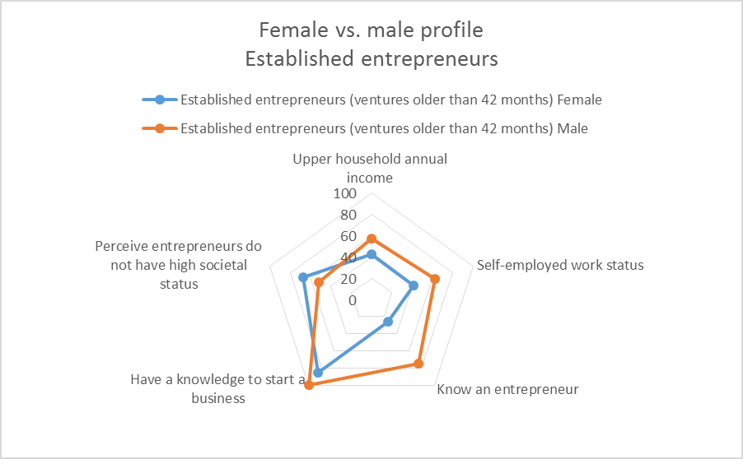

After confirming the first hypothesis of differences in the gender patterns of businesses with growth potential, it was an additional challenge to see if there are significant differentiators between innovative and non-innovative members inside of each cohort (women, men).

*H2: There is a significant difference between* ***innovative and non-innovative women****, based on independent variables clustered as personal demographics, personal attributes and societal values, firm demographics and firm innovation strategies -CONFIRMED*

***Early-stage venturing (non-innovative women and innovative women)***

Innovative women are better connected / networked than non-innovative women (71.3% vs. 59.2% know an entrepreneur), they see more often opportunities than non-innovative women (48.4% vs. 39.2%) and more of them express fear of failure than non-innovative women (78.0% vs. 66.3%. Innovative women are involved in riskier venturing, which could be an explanation for such a result, but it requires more research.

***Established venturing (non-innovative women and innovative women)***

Values of differentiators between non-innovative and innovative women who are involved in established venturing are surprising and against some intuitive expectations, which requires additional research. As it is visible from Table 3b, non-innovative entrepreneurs are better educated, in average they employ three times more people in their firms (9,4 vs. 3,1 in innovative firms), and they expect to create twice more jobs in next 5 years (11.9 vs. 4.8 in innovative firms). Both non-innovative and innovative women have same level of export activities.

*H3: There is a significant difference between* ***innovative and non-innovative men,*** *based on independent variables clustered as personal demographics, personal attributes and societal values, firm demographics and firm innovation strategies - CONFIRMED*

***Early-stage venturing (non-innovative men and innovative men)***

Innovative men are better connected / networked than non-innovative men (72.5% vs. 67.5% know an entrepreneur), they see more often opportunities than non-innovative men (54.8% vs. 47.4%) and more of them expect to start a business in next 3 years (53.2% vs. 47.6%). More innovative men than non-innovative men think that being an entrepreneur is a good career choice (68.6% vs. 62.4%) and that they have high societal status (47.5% vs. 41.4%). Innovative men more often start a business because of opportunity recognition (54.1% vs. 44.6%) and more non-innovative men decide upon venturing because they did not have a better choice (37.1% vs. 32.1%). Businesses owned by innovative men export more than non-innovative business owners (39% vs. 28.8%), but the biggest difference is in the size of present business by number of employees (37.6 in businesses owned by innovative entrepreneurs, and 8.4 in businesses owned by non-innovative men). Innovative men also expect to create 2.5 time more jobs in next 5 years than non-innovative men.

***Established venturing (non-innovative men and innovative men)***

There are much less differentiators among non-innovative and innovative men involved in established businesses. Innovative men are very confident in own knowledge and skills needed to start a business (99.3% of surveyed sample of innovative men think like that, vs. 92.9% of non-innovative men). Innovative men appreciate high societal status for successful entrepreneurs (48%), while less number of non-innovative men think like that (36%). More innovative men (29%) have higher share of their sales from exporting (more than 26%) than non-innovative men (20.3%).

1. **Discussion and conclusions**

The findings presented above confirmed all three hypothesis and enabled conclusion about differentiated gender patterns of businesses with growth potential in Croatia, both for the early-stage businesses and established businesses, as presented in the Figure 8 and Figure 9.

## These findings contribute to verifying expected relationships between personal demographics, personal attributes and societal values, firm demographics and business innovation strategies, using two criteria by which the dependent variable (innovative vs. non-innovative entrepreneur) is defined, i.e. gender and intensity of innovative performance (newness of product, newness of technology and no many competitors). The survey also confirmed the importance of understanding the motivational aspects of an individual in venturing process, in its both phases (early-stage, established).

Literature review revealed that the multifaceted features of firm growth are too often reduced to the size of the firm, which prevented deeper insights into the varieties of factors contributing to growth. The analysis developed in this survey started with the definition of firm growth as based on the innovativeness capacity of a firm (measured by newness of products, intensity of exposure to competitors and newness of implemented technology) which is looked at through gender lenses.

The survey confirmed the multifaceted features of firm growth because it identified a portfolio of influencers, not a single one. Also, the statistical analysis revealed that the portfolio of influencers differ depending on the gender and the phase of the venturing process.

The gender- sensitive influencers identified in this study are in line with several other studies, such as Loscocco et al. (1991), Rosa et al. (1996), or Fairlie and Robb (2009). The majority of identified influencers (motivation / reason to start a venture, expectations about the growth of venture…) are related to individual behavior, which is the basis for understanding the life cycle concept of a firm or firm’s growth, as Greiner (1972) argued, or Cooney (2012) who emphasized the role of owner and his motivation.

The reason for venturing (recognized opportunity or no other choices for work) is a very strong influencer for building innovative businesses, among innovative women and innovative men in early stage of business activity (using GEM criteria, up to 42 months). In later phases of venturing (businesses older than 42 months) the reason for venturing is no longer a strong influencer, but networking capacity, perceptions about personal capabilities (knowledge and skills) and perception how entrepreneurs are seen in the society (societal status) become strong influencers. In both phases of business venturing, identified influencers differ because of gender (women start a venture more often out of lack of other work choices than men, women have lower capacity for networking, women are more critical than men on how the society praises successful entrepreneurs). The only influencer which is gender-free is the perception about own capabilities. Combining this finding with the one reported by Tominc and Rebernik /2006) that women do not start their entrepreneurial ventures with lower expectations than men, is challenging to explore further what makes women’s ventures smaller in size (number of employees).

Identified influencers as export orientation (in the early stage of venturing) and expectations related to job creation (in both phases of venturing) confirm that firm strategy plays an important role in strengthening the growth potential of businesses, jointly with the entrepreneur (motivation) and the firm (size and structure), as it was recognized by Storey (1994).

Differences in portfolios of influencing factors related to the different phases of venturing confirm Adizes’s (1979) conclusion about the need of re-configuration of resources (including individual attributes) and activities along the growth process . The same finding is also in line with Levie and Lichtenstein’s (2010) dynamic states approach which requests a changed network of beliefs, relationships, systems and structures to convert opportunities into ventures.

Adding these findings to what is already known about the development context of Croatia (high unemployment, the lowest employment rate in the European Union - 63% expected for 2020 vs. 75% for the EU average) confirms that the overall low innovation capacity of the Croatian economy and differences in gender patterns of innovativeness contribute to economic and social vulnerability of Croatia. In order to change this situation, it is necessary to look at growing businesses from the gender perspective as a part of value adding chain in building sustainable competitiveness of a country. New job creation is a result of higher competitiveness, and higher competitiveness depends on continuous innovativeness (in products, processes, business models, markets…). Innovativeness is result of human activity – therefore everyone is invited to participate in this process. The gender differences identified in building the innovative capacity of Croatian economy is a call for researchers to investigate further to which extent this gender gap is related to the entrepreneurship eco-system. Otherwise, women will remain “unexploited resources for entrepreneurship” (Tominc and Rebernik, 2006). .

## The analysis developed in this study contributed to answering many questions, but as research always does, many new questions emerged. The differences in the cohort of women, between innovative and non-innovative established entrepreneurs are surprising, because non-innovative women appear to be more entrepreneurial (they export more, they expect to create more jobs…). This requires additional, in-depth research. Other questions also emerge - are women less ambitious than men (looking at the expected job creation, yes; looking at exporting, yes), but those findings do not give insights into how an entrepreneurial eco-system interferes with motivational differences between women and men. Existing business models do not sufficiently consider the gender dimension, and an entrepreneurial eco-system should also take more into account the different life agendas of women and men Entrepreneurial eco-systems that prevent women to participate in these activities equally to men have to be identified and re-designed. Despite the fact that GEM is collecting data on individuals (through Adult Population Survey) and on entrepreneurial eco-system (through National Expert Survey) those two databases are not sufficiently used for detecting types and strengths of their interactions. Those questions are challenges for further research.

The aim of this analysis was to identify statistically relevant influencers in understanding gender sensitive patterns of innovativeness in Croatian economy. All three hypothesis were confirmed, and that provides a good start to work on identifying their predicting capacity. As Kolvereid and Bullvag (1996) concluded that growth intentions can predict actual growth, further research could check if predicting the growth potential by using intentions or some other identified influencers are gender-free.

In the meantime, policy-makers in Croatia can use these gender patterns findings in businesses with growth potential and design more policy instruments and programs for innovative entrepreneurs. Unemployment issues, low competitiveness and low employment levels can be challenged by an increasing share of businesses with growth potential. It will take time to have an impact on the economic situation, but without it, it will never happen.

Appendix:

Table 1 - List of variables and GEM APS related questions

|  |  |  |  |
| --- | --- | --- | --- |
| Code and variable category | |  |  |
| Personal demographics | | | |
| Gender | Female  Male | What is your gender? | |
| Age |  | What is your age (in years)? | |
| Hhsize |  | How many members make up your permanent household, including you? | |
| Gemwork3 | Working  Not working  Student/Retired | Working status? | |
| Gemhhinc | Lower  Middle  Upper | Which of these ranges best describes the total annual income of all the members of your household, including your income, as one combined figure? | |
| Gemoccu | Full/Part time  Part  Retired, disabled  Homemaker  Student  Not-working  Self-employed | What of the following describes your current employment status? | |
| Gemeduc | Some secondary  Secondary  Post-secondary  Graduate | What is the highest level of education you have completed? | |
|  | | | |
| Personal attributes and societal values | |  |  |
| Knowent | No  Yes | Do you know someone personally who started a business in the past 2 years? | |
| Opport | No  Yes | In the next six months, will there be good opportunities for starting a business in the area where you live? | |
| Suskill | No  Yes | Do you have the knowledge, skill and experience required to start a new business? | |
| Fearfail | No  Yes | Would fear of failure prevent you from starting a business? | |
| Futsup | No  Yes | Are you, alone or with others, expecting to start a new business, including any type of self-employment, within the next three years? | |
| Nbgoodc | No  Yes | In my country, most people consider starting a new business a desirable career choice. | |
| Nbstatus | No  Yes | In my country, those successful at starting a new business have a high level of status and respect. | |
| Nbmedia | No  Yes | In my country, you will often see stories in the public media about successful new businesses. | |
| Sureason/Omreason | Opportunity  No better choice  Both  Have a job but seek better  Other | Are you involved in this start-up to take advantage of a business opportunity or because you have no better choices for work? | |
|  | | | |
| Firm demographics | | | |
| Suowners |  | How many people, including yourself, will own this new business? | |
| Omnowners |  | How many people, including yourself, both own and manage this business? | |
| Sunowjob/Omnowjob |  | Not counting the owners, how many people are currently working for this business? | |
|  | | | |
| Firm innovation strategy | | | |
| Sunewcst/Omnewcst | All  Some  None | Will all, some, or none of your potential customers consider this product or service new and unfamiliar? | |
| Sunewtec/Omnewtec | Less than a year  Between one to five years  Longer than five years | How long have the technologies or procedures required for this product or service been available? | |
| Sucompet/Omcompet | Many  Few  No | Right now, are there many, few, or no other businesses offering the same products or services to your potential customers? | |
| Suexport/omnexport | More than 90%  76-90%  51-75%  26-50%  11-25%10% or less  None | What proportion of your customers will normally live outside the country? | |
| Suyr5job/omxt5job |  | Not counting owners, how many people will be working for this business five years from now? | |

Table 2a

Significant differentiators of innovative women and innovative men, across the development phases of businesses, Croatia

|  |  |  |  |
| --- | --- | --- | --- |
| Variable | | Early stage (less than 42 month old ventures) | Established ventures (more than 42 months old ventures) |
| Personal demographics | Age  Hhsize  Gemwork3  Gemhhinc  Gemoccu  Gemeduc | ***  *** | *  *  * |
| Personal attributes and social values | Knowent  Opport  Suskill  Fearfail  Futsup  Nbgoodc  Nbstatus  Nbmedia  Sureason/Omreason | ** | ***  ***  * |
| Firm demographics | Suowners/Omnowners  Sunowjob/Omnowjob |  | ** |
| Firm innovation strategy | Suexport/omnexport  Suyr5job/omxt5job | ***  * | * |

statistical significance ***1% **5% *10%

Table 2b - Innovative women vs. innovative men: values of statistically significant variables – in % of total value for a respective variable or average number

|  |  |  |  |  |  |
| --- | --- | --- | --- | --- | --- |
|  |  | Early-stage entrepreneurs (ventures less old than 42 months) | | Established entrepreneurs (ventures older than 42 months) | |
|  |  | Women | Men | Women | Men |
| Household size  (Hhsize) | Average number |  |  | 3..4 | 3.8 |
| Household annual income (gemhhinc) | Upper | 44.4 | 56.8 | 42.4 | 57.3 |
| Work status  (gemoccu) | Full or part time  Self-employed | 50.5  22.3 | 46.1  30.0 | 41.1 | 62.2 |
| Know an entrepreneur  (knowent) | Yes |  |  | 25.7 | 74.3 |
| Have a knowledge to start a business  (suskill) | Yes |  |  | 84.9 | 99.3 |
| High societal status  (nbstatus) | No |  |  | 67.2 | 52.2 |
| Reason to be involved in the business  (Sureason/Omreason) | Take the advantage of opportunity  No better choice for work | 40.4  42.9 | 54.1  32.1 |  |  |
| Number of employees  (Sunowjob/Omnowjob) | Average number |  |  | 3.1 | 13.9 |
| Export orientation  (Sureason/Omreason) | 0%  26-75%  75% + | 32.6  11.8  11.5 | 30.7  22.9  16.1 |  |  |
| New jobs in 5 years  (Suyr5job/omxt5job) | Average number | 12.3 | 34.8 | 4.8 | 20.1 |

Table 3a - Significant differentiators of innovative women and non-innovative women, across the development phases of businesses

|  |  |  |  |
| --- | --- | --- | --- |
| Variable | | Early stage (less than 42 month old ventures) | Established ventures (more than 42 months old ventures) |
| Personal demographics | Age  Hhsize  Gemwork3  Gemhhinc  Gemoccu  Gemeduc |  | *  *  * |
| Personal attributes and social values | Knowent  Opport  Suskill  Fearfail  Futsup  Nbgoodc  Nbstatus  Nbmedia  Sureason/Omreason | **  *  ** |  |
| Firm demographics | Suowners/Omnowners  Sunowjob/Omnowjob |  | * |
| Firm innovation strategy | Suexport/omnexport  Suyr5job/omxt5job |  | **  * |

statistical significance ***1% **5% *10%

Table 3b

Non-innovative women vs. innovative women: values of statistically significant variables – in % of total value for a respective variable or average number

|  |  |  |  |  |  |
| --- | --- | --- | --- | --- | --- |
|  |  | Early-stage entrepreneurs (ventures less old than 42 months) | | Established entrepreneurs (ventures older than 42 months) | |
|  |  | Women non-innovative | Women innovative | Women non-innovative | Women  Innovative |
| Household size  (Hhsize) | Average number |  |  | 3,8 | 3,4 |
| Work status  (gemoccu) | Full or part time  Self-employed |  |  | 29,2  57,4 | 35,0  41,1 |
| Educational attainment  (Gemeduc) | Some secondary  Secondary  Post-secondary |  |  | 23,1  60,7  36,9 | 32,9  43,2  24,0 |
| Know an entrepreneur  (knowent) | Yes | 59,2 | 71,3 |  |  |
| Seeing opportunity in next 6 months  (Opport) | Yes | 39,2 | 48,4 |  |  |
| Fear of failure  (Fearfail) | No | 66,3 | 78,0 |  |  |
| Number of employees  (Sunowjob/Omnowjob) | Average number |  |  | 9,4 | 3,1 |
| Export orientation  (Sureason/Omreason) | 0%  26-75%  75% + |  |  | 39,2  13,6  7,0 | 42,2  10,1  9,1 |
| New jobs in 5 years  (Suyr5job/omxt5job) | Average number |  |  | 11,9 | 4,8 |

Table 4a - Significant differentiators of innovative men and non-innovative men, across the development phases of businesses

|  |  |  |  |
| --- | --- | --- | --- |
| Variable | | Early stage (less than 42 month old ventures) | Established ventures (more than 42 months old ventures) |
| Personal demographics | Age  Hhsize  Gemwork3  Gemhhinc  Gemoccu  Gemeduc | *  * | * |
| Personal attributes and social values | Knowent  Opport  Suskill  Fearfail  Futsup  Nbgoodc  Nbstatus  Nbmedia  Sureason/Omreason | *  **  *  *  *  *  * | ***  ** |
| Firm demographics | Suowners/Omnowners  Sunowjob/Omnowjob | **  ** |  |
| Firm innovation strategy | Suexport/omnexport  Suyr5job/omxt5job | ***  * | *** |

statistical significance ***1% **5% *10%

Table 4b - Non-innovative men vs. innovative men: values of statistically significant variables – in % of total value for a respective variable or average number

|  |  |  |  |  |  |
| --- | --- | --- | --- | --- | --- |
|  |  | Early-stage entrepreneurs (ventures less old than 42 months) | | Established entrepreneurs (ventures older than 42 months) | |
|  |  | Men non-innovative | Men innovative | Men non-innovative | Men innovative |
| Age | Average number | 36,9 | 36,5 | 45,5 | 43,7 |
| Household annual income  (gemhhinc) | Upper | 50,5 | 56,8 |  |  |
| Educational attainment  (Gemeduc) | Some secondary  Secondary  Post-secondary | 33,2  42,0  24,8 | 32,9  35,7  31,4 |  |  |
| Know an entrepreneur  (knowent) | Yes | 67,5 | 72,5 |  |  |
| Seeing opportunity in next 6 months  (Opport) | Yes | 47,4 | 54,8 |  |  |
| Have a knowledge to start a business  (suskill) | Yes |  |  | 92,9 | 99,3 |
| Expect to start a business in next 3 years  (Futsup) | Yes | 47,6 | 53,2 |  |  |
| Starting a business is a good career choice  (ngoodc) | Yes | 62,4 | 68,6 |  |  |
| High societal status  (nbstatus) | Yes | 41,4 | 47,5 | 36,0 | 48,0 |
| Media celebrates successful businesses  (nbmedia) | Yes | 51,2 | 45,4 |  |  |
| Reason to be involved in the business  (Sureason/Omreason) | Take the advantage of opportunity  No better choice for work | 44,6  37,1 | 54,1  32,1 |  |  |
| How many people own and manage this business  (Suowners/Omnowners) |  | 2,5 | 1,8 |  |  |
| Number of employees  (Sunowjob/Omnowjob) | Average number | 8,4 | 37,6 |  |  |
| Export orientation  (Sureason/Omreason) | 0%  26-75%  75% + | 31,5  17,8  11,0 | 30,7  22,9  16,1 | 29,6  13,8  6,5 | 38,3  22,5  6,5 |
| New jobs in 5 years  (Suyr5job/omxt5job) | Average number | 14,1 | 34,8 |  |  |

References:

Adizes I. (1979). Organizational passages—diagnosing and treating lifecycle problems of organizations. Organizational Dynamics, 8:3–25

Allen, I.E., Elam, A., Langowitz, N., Minniti, M. (2007) 2006 Report on Women and Entrepreneurship

Allen, I.E., Elam, A., Langowitz, N., Dean, M. (2008), Global Entrepreneurship Monitor 2007 Report on Women and Entrepreneurship

Autio, E. (2006) Global Entrepreneurship Monitor 2005 Report on High-Expectation Entrepreneurship, London Business School, Babson College, Mazars

Autio, E. (2007) Global Entrepreneurship Monitor 2007 Global Report on High-Growth Entrepreneurship, London Business School, Babson College

Bartelsman, E, Scarpetta, S and Schivardi, F. (2005). ‘Comparative analysis of firm demographics and survival: evidence from micro-level sources in OECD countries’, Industrial and Corporate Change, Vol. 14, pp. 365-391.

Coleman, S. and Robb A. (2014). Access to Capital by High-Growth Women-Owned Businesses SBAHQ-13-Q-0A63, The National Women’s Business Council, USA

Cooney, T.M. (2012). Entrepreneurship Skills for Growth-Orientated Businesses, Report for the Workshop on ‘Skills Development for SMEs and Entrepreneurship’, OECD, Copenhagen, 28 November 2012

Davidsson, P. (1989). Entrepreneurship—and after? A study of growth willingness in small firms. Journal of Business Venturing, 4, 211–226.

Delmar, F., Davidsson, P., & Gartner, W. (2003). Arriving at the high-growth firm. Journal of Business Venturing, 18, 198-207

Entrepreneurship, Competitiveness and Development, Global Entrepreneurship Monitor and World Economic Forum, 2015

Fairlie, R.W. and Robb, M.A. (2009). Gender Differences in Business Performance: Evidence from the Characteristics of Business Owners Survey, Santa Cruz Department of Economics, Working Paper Series from Department of Economics, UC Santa Cruz

GEM database, Croatia GEM team, CEPOR, 2016

Gibb A.A. (2000).SME policy, academic research and the growth of ignorance, mythical concepts, myths, assumptions, rituals and confusions.International Small Business Journal 18(3):13–36.

The Global Competitiveness Report 2015–2016, the World Economic Forum, 2015

The Global Gender Gap Report 2015, The World Economic Forum, 2015

Greiner L (1972). Evolution and revolution as organizations grow. Harvard business review. July-August, 50:37-46

Gupta, P., Guha, S., & Krishnaswami, S. (2013). Firm growth and its determinants. Journal of Innovation and Entrepreneurship. 2:15

2011 High-Impact Entrepreneurship Global Report, Endeavor, Global Entrepreneurship Monitor

Innovation Union Scoreboard 2015, European Union, 2015

Johnsen, G.J. and McMahon, R.G.P. (2005). Owner-manager Gender, Financial Performance and Business Growth amongst SMEs from Australia’s Business Longitudinal Survey, International Small Business Journal, vol. 23, 2: pp. 115-142.

Katz, J. & Gartner, W. (1988). Properties of emerging organizations. Academy of Management Review, 13, 429-441.

Kelley, J.D., Brush, G. C., Greene, G. P., Litovsky, Y. (2011). Global Entrepreneurship Monitor 2010 Report: Women Entrepreneurs Worldwide

Kelley, J.D., Brush, G. C., Greene, G. P., Litovsky, Y. (2013). Global Entrepreneurship Monitor 2012 Women’s Report

Kelley, J.D., Brush, G. C., Greene, G. P., Herrington, M., Ali, A., Kew, P. (2015). Global Entrepreneurship Monitor Women’s Entrepreneurship

Kelley, D., Singer, S. and Herrington, M. (2016). 2015/16 Global report, 2016

Kolvereid, L. and Bullvag, E. (1996). Growth intentions and actual growth: The impact of entrepreneurial choice, J. Enterprising Culture 04, 1

Leitch C, Hill F, Neergaard H. (2010). Entrepreneurial and business growth and the quest for a ‘comprehensive theory’: tilting at windmills? Entrepreneurship Theory and Practice, 34(2):249–260.

Levie J, Lichtenstein B. (2010). A terminal assessment of stages theory: introducing a dynamic states approach to entrepreneurship**.** *Entrepreneurship: Theory & Practice* 34(2):317–350.

Lichtenstein, B. (2014). Generative Emergence, A New Discipline of Organizational, Entrepreneurial, and Social Innovation, Oxford University Press

Loscocco, A.K., Robinson, J., Hall, H. R., and Allen, K.J. (1991). Gender and Small Business Success: An Inquiry into Women's Relative Disadvantage, Social Forces.70 (1): 65-85

Lumpkin, T., and Dess, G. (1996). Clarifying the entrepreneurial orientation construct and linking it to performance. Academy of Management Review, 21(1), 135–172.

Pines, M. A., Lerner, M. and Schwartz, D. (2010). Gender differences in entrepreneurship: Equality, diversity and inclusion in times of global crisis. Equality, Diversity and Inclusion: An International Journal Vol. 29 No. 2, pp. 186-198, Emerald Group Publishing Limited

Orser, B. (1997) - Understanding the Influence of Intention, Managerial Capacity and Gender on Small Firm Growth - PhD. Thesis, Bradford University School of Management

Penrose, E. (1959). The theory of the growth of the firm, Revised edition published 2009. Oxford University Press

Robichaud, Y., LeBrasseur, R. and Nagarajan, K. V. (2010). Necessity and Opportunity-driven Entrepreneurs in Canada: An Investigation into their Characteristics and an Appraisal of the Role of Gender, Journal of Applied Business and Economics, 11(1), pp. 59-79.

Rosa, P., Carter, S.L. and Hamilton, D. (1996) Gender as a determinant of small business performance: insights from a British study. Small Business Economics, 8 (6). pp. 463-478.

Sarasvathy, S.D. (2001). Causation and effectuation: Toward a theoretical shift from economic inevitability to entrepreneurial contingency. Academy of Management Review, 26(2), 243264.

Shane, S., & Venkataraman, S. (2000). The promise of entrepreneurship as a field of research. Academy of Management Review, 25, 217-226.

Sheskin, D.J. (2004). “*Handbook of parametric and nonparametric statistical procedures”*, Chapman & Hall/CRC, Washingon D.C.

Slevin, D. and Covin, J. (1997). “Time, growth, complexity, and transitions: Entrepreneurial challenges for the future,” Entrepreneurship: Theory and Practice, ISSN 1042-2587, 22(2-Winter): 53-68.

Storey, D.J. (1994). Understanding the Small Business Sector. 1st Edition, Routledge, London.

Šarlija, N., Pfeifer, S. (2015): Differences in Innovative Orientation of the Entrepreneurially Active Adults: The Case of Croatia, World Academy of Science, Engineering and Technology International Journal of Social, Education, Economics and Management Engineering Vol. 9, No:4

Tominc, P., Rebernik, M. (2006). Growth Aspirations of Slovenian Entrepreneurs – A Gender Differences Perspective. Management, Vol. 11, 2006, 1, pp. 37-52

Tominc, P., Rebernik, M., Bradač Hojnik, B. and Širec, K. (2015). Danube Region: Entrepreneurship Observatory: Diversity and Potential, Pearson, London

About the authors:

SLAVICA SINGER

Slavica Singer is Professor Emeritus and UNESCO Chair in Entrepreneurship Education at the J.J. Strossmayer University in Osijek, Croatia. She holds an honorary doctorate from the Turku School of Economics, Finland. Slavica is Croatia Global Entrepreneurship Monitor team leader, from 2002 and very active in researching women entrepreneurship in Croatia. She is a board member of the Global Entrepreneurship Research Association, the oversight board of the GEM project. She co-authored the GEM Global 2011 Report and a 2013 GEM special topic report on entrepreneurial employee activity, as well as the GEM reports for Croatia.

NATAŠA ŠARLIJA

Nataša Šarlija is a full professor at the University of J.J. Strossmayer in Osijek, Faculty of Economics in Osijek, Croatia. Her research interests are in credit risk modeling, high growth entrepreneurship, credit analysis, financial modeling. She has published research on the topics of credit risk modeling and entrepreneurship. Besides the university career, Nataša’s experience includes owing and managing a small IT business. She is the member of the GEM Croatia team and co-authored the GEM reports for Croatia.

SANJA PFEIFER

Sanja Pfeifer is a tenured professor at the University of J.J. Strossmayer in Osijek, Faculty of Economics in Osijek, Croatia. She is one of the founders of Entrepreneurship Research and Education Network which gathers teachers and researchers of entrepreneurship in eastern and central Europe. Sanja published research in entrepreneurship and small business journals on the topics of entrepreneurial intentions, management and entrepreneurial educations. Her present research is focused on creative industries. She is the member of GEM Croatia Team and co-authored the GEM reports for Croatia.

SUNČICA OBERMAN PETERKA

Sunčica Oberman Peterka is an associated professor at the University of J.J. Strossmayer in Osijek, Faculty of Economics in Osijek, Croatia. Her research interests are in Triple Helix concept, entrepreneurial university, entrepreneurial education and start-up businesses. Sunčica published research in Triple Helix and entrepreneurial education. She is the member of GEM Croatia Team and co-authored the GEM reports for Croatia.

1. Businesses with growth potential in this survey are defined by using three dimensions: (a) newness of the product – only if a product is new to all customers(GEM question: Will all, some, or none of your potential customers consider this product or service new and unfamiliar?); (b) low exposure to competition – only if there are no other businesses offering the same product to the same target group of customers (GEM question: Right now, are there many, few, or no other businesses offering the same products or services to your potential customers? and (c) newness of used technologies or procedures – only if required technologies or procedures for making this product is available less than a year (GEM question: How long have the technologies or procedures required for this product or service been available?)
2. Using GEM data of nine countries from 2013 (except for Austria, for which 2012 data were available): Austria, Bosnia and Herzegovina, Croatia, Czech Republik, Germany, Hungary, Slovakia, Slovenia and Romania.